Tables and Figures file
Table 1. Standardized effect sizes (SES) of observed taxonomic and functional beta diversity in urban greenspaces of Cleveland, Ohio, USA. Positive SES values indicate observed beta-diversity metrics are higher than average null model expectations, while negative SES values indicate observed beta-diversity metrics are lower than average null model expectations.
Beta Diversity Metric |  | Components | SES | p-value
Taxonomic  Functional |  | Turnover  Nestedness  Turnover  Nestedness | -49.437  -62.555  49.738  3.653  -0.097  3.170 | < 0.001  < 0.001  < 0.001  < 0.001  0.629  < 0.001
 | Note. Beta diversity calculated through Sørensen’s dissimilarity index. SES is the pseudo median SES calculated from all the sites in Cleveland. Alpha level for significant p value set at 0.05 a priori. Significant p-values have been bolded.

Table 2. Standardized effect sizes (SES) of observed functional traits in urban greenspaces of Cleveland, Ohio. Positive SES values indicate the functional trait category was observed at higher rates than in the average null model expectations, while negative SES values indicate lower observations than average null model expectations.
Trait |  | Category | SES | p-value
Body Length  Lecty  Nesting type  Sociality  Origin |  | Kleptoparasitic  Generalist  Specialist  Soil  Cavity  Hive  Pithy Stem  Wood  Subsocial  Solitary  Eusocial  Parasitic  Native  Non-native | -0.887  -2.357  4.145  -2.588  -2.592  1.106  2.410  0.606  0.976  2.623  -1.656  2.967  -2.487  -4.453  4.453 | < 0.001  < 0.001  < 0.001  < 0.001  < 0.001  < 0.001  < 0.001  < 0.001  < 0.001  < 0.001  < 0.001  < 0.001  < 0.001  < 0.001  < 0.001
 | Note. SES is the pseudo median SES calculated from all of the sites in Cleveland. Alpha level for significant p value set at 0.05 a priori. Significant p-values have been bolded.

Table 3. SES values of observed taxonomic and functional diversity metrics in each treatment of urban greenspaces in Cleveland, Ohio, USA. Positive SES values indicate observed beta-diversity metrics are higher than average null model expectations of the city. Negative SES values indicate observed beta-diversity metrics are lower than Cleveland’s average null model expectations.
Note: The description above has not been edited, but is being retained in case there is anything useful for the rewriting stage.

Diversity Metric |  | Components | Urban Farms |  | Vacant Lots |  |  |  | High Diversity Prairies
 |  |  | SES | p-value |  | SES | p-value | SES |  | p-value
Taxonomic Beta  Functional Beta  Functional Alpha |  | Turnover  Nestedness  Turnover  Nestedness | 3.630  0.485  -0.761  4.176  1.289  3.561  -0.832 | 0.008  0.383  0.313  0.008  0.023  0.008  0.023 |  | 3.403  -0.194  0.210  3.684  1.133  3.236  -0.761 | < 0.001  0.487  0.487  < 0.001  0.001  < 0.001  0.001 | 2.673  -0.355  0.187  2.877  0.484  3.083  0.223 |  | 0.008  0.461  0.844  0.008  0.109  0.008  0.383
 | Note. SES is the pseudo median SES calculated from all of the sites in Cleveland. Alpha level for significant p- value set at 0.05 a priori. Significant p-values have been bolded.

Table 4. Standardized effect sizes (SES) of observed functional trait groups in urban farms, and vacant lots in Cleveland, Ohio, USA. Positive SES values indicate the functional trait category was observed at higher rates than in the average null model expectations of the city. Negative SES values indicate the functional group was observed at rates lower than Cleveland’s average null model expectations.
Note: the above test is being retained for purposes of potentially making it easier to rewrite table descriptions in the next document draft. But it is not up to date. Currently I’m separating Francis and Katie’s results completely. Below is the table of SES values when comparing the Francis data to the null
Trait |  | Category | Vacant Lots(control) |  | Urban Farms
 |  |  | SES | p-value |  | SES | p-value
Body Length  Lecty  Nesting type  Sociality  Origin |  | Kleptoparasitic  Generalist  Specialist  Soil  Cavity  Hive  Pithy Stem  Wood  Subsocial  Solitary  Eusocial  Parasitic  Native  Non-native | 0.068  -2.113  2.376  -0.934  0.073  -0.755  1.380  -0.016  0.300  2.111  -1.076  1.898  -2.295  -0.680  0.680 | 0.910  0.004  0.004  0.008  0.734  0.039  0.020  1.000  0.164  0.004  0.012  0.004  0.004  0.055  0.055 |  | 0.080  -1.935  1.869  -0.295  0.664  -1.486  1.114  0.054  -0.131  1.781  -1.412  1.857  -2.174  -0.359  0.359 | 0.844  0.016  0.016  0.25  0.0547  0.008  0.039  0.945  0.742  0.008  0.008  0.008  0.008  0.313  0.313
 | Note. SES is the pseudo median SES calculated from all of the sites in Cleveland. Alpha level for significant p value set at 0.05 a priori. Significant p-values have been bolded.

Below is the table of SES values when comparing Katie’s data to the null

Trait |  | Category | Vacant Lots |  |  | High Diversity Prairies
 |  |  | SES | p-value | SES |  | p-value
Body Length  Lecty  Nesting type  Sociality  Origin |  | Kleptoparasitic  Generalist  Specialist  Soil  Cavity  Hive  Pithy Stem  Wood  Subsocial  Solitary  Eusocial  Parasitic  Native  Non-native | 0.186  -1.768  2.374  -1.535  -0.680  -0.048  2.153  0.084  0.083  1.185  -0.509  1.302  -1.927  -1.620  1.620 | 0.742  0.008  0.008  0.008  0.078  0.945  0.039  0.945  0.742  0.023  0.195  0.016  0.008  0.023  0.023 | 0.921  -1.633  2.289  -1.436  -1.843  0.232  3.569  0.608  -0.791  1.427  -0.774  1.440  -1.711  -2.079  2.079 |  | 0.055  0.008  0.008  0.008  0.008  0.844  0.008  0.109  0.016  0.016  0.195  0.023  0.008  0.008  0.008
 | Note. SES is the pseudo median SES calculated from all of the sites in Cleveland. Alpha level for significant p value set at 0.05 a priori. Significant p-values have been bolded.

Table 5. Results from generalized linear models examining the standardized effect sizes (SES) of bee diversity indices to landscape and local predictors in Cleveland, Ohio, USA. Significant models had a better fit than the null (i.e. intercept) model. Fixed effects included represent the best fit model after backward model selection. Local habitat management treatments (TRT) were urban farms, vacant lots, and high diversity pocket prairies. Landscape variables included percentage of the landscape that was greenspace (PLAND), greenspace largest patch index (LPI), and greenspace isolation (ENN, Euclidean Nearest Neighbor Distance).
Note: the above description will need to be edited for relevance to the actual data. It has not been touched but is being retained in case some of the words can be recycled.
Diversity Type |  | Predictors | LR Chisq | Df | p-value
Taxonomic Beta  Taxonomic Turnover  Taxonomic Nestedness  Functional Alpha  Functional Beta  Functional Turnover  Functional Nestedness |  | ENN  ENN  Intercept  TRT  TRT  Intercept  Intercept | 4.90  2.46  -  12.28  3.93  -  - | 1  1  -  2  2  -  - | 0.027  0.117  -  0.002  0.140  -  -
 | Note. Alpha level for significant p value set at 0.05 a priori. Significant p-values have been bolded.

Table 6. Results from generalized linear models examining the standardized effect sizes (SES) of bee traits to landscape and local predictors in Cleveland, Ohio, USA. Significant models had a better fit than the null (i.e. intercept) model. Fixed effects included represent the best fit model after backward model selection. Local habitat management treatments (TRT) were urban farms, vacant lots, and high diversity pocket prairies. Landscape variables included percentage of the landscape that was greenspace (PLAND), greenspace largest patch index (LPI), and greenspace isolation (ENN, Euclidean Nearest Neighbor Distance).

Below is for the Francis glm
Trait | Category | Predictors | LR Chisq | Df | p-value
Body Length  Lecty  Nesting type  Sociality  Origin | Body Length  Kleptoparasitic  Generalist  Specialist  Soil  Cavity  Hive  Pithy Stem  Wood  Subsocial  Solitary  Eusocial  Parasitic  Native  Non-native | PLAND  LPI  ENN  Intercept  Intercept  TRT  LPI  PLAND  TRT  Intercept  Intercept  Intercept  TRT  LPI  Intercept  Intercept  Intercept  Intercept  ENN  ENN | 6.03  5.62  11.98  -  -  2.39  5.49  3.73  4.04  -  -  -  4.10  5.75  -  -  -  -  7.35  7.35 | 1  1  1  -  -  1  1  1  1  -  -  -  1  1  -  -  -  -  1  1 | 0.014  0.018  0.001  -  -  0.122  0.019  0.054  0.044  -  -  -  0.043  0.016  -  -  -  -  0.007  0.007
Note. Alpha level for significant p value set at 0.05 a priori. Significant p-values have been bolded.
Katie glm
Trait | Category | Predictors | LR Chisq | Df | p-value
Body Length  Lecty  Nesting type  Sociality  Origin | Body Length  Kleptoparasitic  Generalist  Specialist  Soil  Cavity  Hive  Pithy Stem  Wood  Subsocial  Solitary  Eusocial  Parasitic  Native  Non-native | Intercept  Intercept  Intercept  Intercept  Intercept  Intercept  TRT  TRT  PLAND  ENN  TRT  PLAND  ENN  Intercept  Intercept  ENN  Intercept  Intercept | -  -  -  -  -  -  3.98  2.46  12.26  9.44  5.61  8.84  12.13  -  -  4.82  -  - | -  -  -  -  -  -  1  1  1  1  1  1  1  -  -  1  -  - | -  -  -  -  -  -  0.046  0.117  <0.001  0.002  0.018  0.003  <0.001  -  -  0.028  -  -
Note. Alpha level for significant p value set at 0.05 a priori. Significant p-values have been bolded.

Vacant lot glm
Note: In cases of violations of normality and homogeneity for this comparison, we ran a Kruskal-wallis test comparing the two TRTs only. Those cases are indicated with an asterix. (we might consider just comparing TRT for everything, but that is a discussion to be had with Mary)
Trait | Category | Predictors | LR Chisq | Df | p-value
Body Length  Lecty  Nesting type  Sociality  Origin | Body Length  Kleptoparasitic  Generalist  Specialist  Soil*  Cavity  Hive  Pithy Stem*  Wood  Subsocial  Solitary*  Eusocial  Parasitic  Native  Non-native | Intercept  Intercept  Intercept  TRT  PLAND  TRT*  Intercept  Intercept  TRT*  LPI  ENN  TRT  PLAND  ENN  TRT*  Intercept  Intercept  Intercept  Intercept | -  -  -  12.11  5.01  2.68  -  -  0.01  6.01  1.88  15.51  2.11  9.47  0.23  -  -  -  - | -  -  -  1  1  1  -  -  1  1  1  1  1  1  1  -  -  -  - | -  -  -  0.001  0.025  0.102  -  -  0.923  0.014  0.171  <0.001  0.146  0.002  0.630  -  -  -  -
Note. Alpha level for significant p value set at 0.05 a priori. Significant p-values have been bolded.

Figure 1- Significant treatment effects across species functional groups – a panel of the groups where trt was a significant predictor and the functional group was significantly different from the null model of the city.
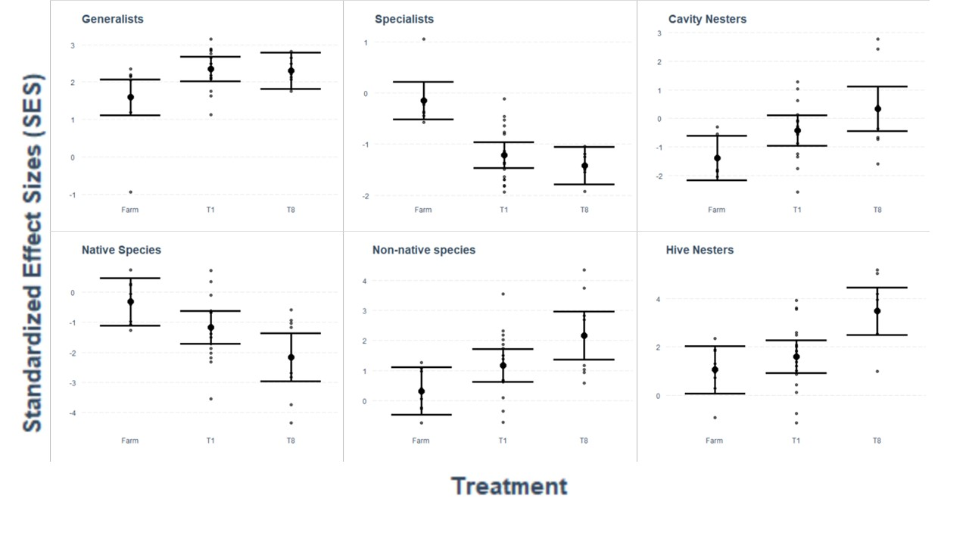

Figure 2- graph of LPI as a predictor of the SES for specialist bee species in comparison of the functional group proportion in vacant lots compared to a null based on the bees found in Cleveland.
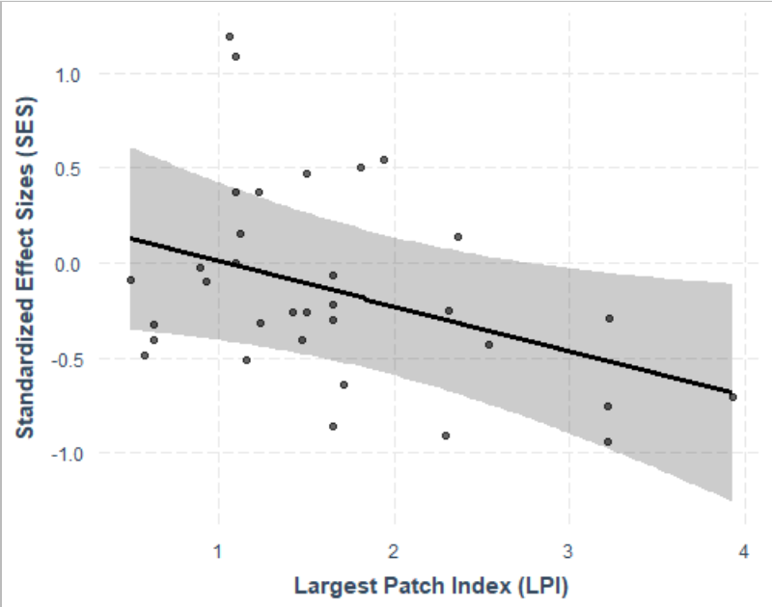

Figure 3- graph of significant predictors of subsocial species- percentage greenspace (PLAND) and ENN as predictors of SES in comparisons between the functional group found in vacant lot to the null models based on Cleveland’s species pool.
